Work Package 7

Deliverable 7.2

Framework for patient involvement in industry-led medicines R&D

Authored by: the EUPATI IMI project

Table of Contents

Overarching principles for patient involvement throughout the medicines research and development process 4
1. Disclaimer 5
2. Introduction to patient involvement in industry-led medicines R&D 5
3. Scope 6
4. Defining ‘Patient’ 6
5. Operating procedures 7
6. Defining the interaction 7
7. Patient identification / interaction 8
8. Written agreement 8
9. Compensation 8
10. Events and Hospitality 9
11. Transparency 9
Appendix 1 – Practical roadmap on Patient Involvement in R&D 10
Appendix 2 – Template: Declaration of interest form 11
Appendix 3 – Template: Confidentiality agreement 13
Appendix 4 – Example written agreement 14
Appendix 5 – Codes of Practice Reviewed 15

Overarching principles for patient involvement throughout the medicines research and development process

The great majority of experts involved in the development and evaluation of medicines are scientists. There is an increasing need to understand what it is like to live with a specific condition, how care is administered and the day-to-day use of medicines and to draw on this experience and specific knowledge of patients in order to promote discovery of new effective drugs and improve their development and evaluation.

Structured interaction between patients, their representatives and other stakeholders is necessary and allows the exchange of information and constructive dialogue at national and European level where the views from users of medicines can and should be considered.
We recommend close cooperation and partnership between the various stakeholders including healthcare professionals’ organisations, patients’ and consumers’ organisations, academia, scientific and academic societies, regulatory authorities and health technology assessment (HTA) bodies and the pharmaceutical industry. Experience to date demonstrates that close cooperation with patients has resulted in increased transparency, trust and mutual respect between them and other stakeholders. It is acknowledged that their contribution to the discovery, development and evaluation of medicines enriches the quality of the evidence and opinion available.

Existing codes of practice for patient involvement with various stakeholders do not cover the research and development (R&D) period. Where frameworks already exist, they have been written for use by a specific body (for example the European Medicines Agency, EMA). The EUPATI framework aims to support the development of patient involvement across the entire process of medicines development and evaluation.
The framework is presented as four separate guidance documents covering patient involvement in:
- pharmaceutical industry-led medicines R&D
- ethics committees
- regulatory authorities
- health technology assessment (HTA).
Each guidance suggests areas where at present there are opportunities for patient involvement. This guidance covers industry-led medicines R&D.

Disclaimer

EUPATI has developed the following Guidance in order to provide a standardised framework applicable to all companies and patients/patient organisations aiming to interact on medicines research and development throughout the medicines R&D lifecycle.
This document serves as a template to be used by pharmaceutical companies and patients/patient organisations interested in strengthening their interaction. Users may modify this template according to specific circumstances – the unique needs of each interaction - and available resources. This guidance must be adapted for individual requirements using professional judgment.
Where this guidance offers advice on legal issues, it is not offered as a definitive legal interpretation and is not a substitute for formal legal advice. If formal advice is required, companies and patients/patient organisations should consult their own legal department or advisors. All subsequently developed guidance should be aligned with existing legislation covering interactions between the pharmaceutical industry and the public.
This guidance should be periodically reviewed and, as needed, revised to adapt to evolutions in best practice for patient involvement in industry-led medicines R&D.
EUPATI will in no event be responsible for any outcomes of any nature resulting from the use of this template.

Introduction to patient involvement in industry-led medicines R&D
The importance and merits of greater patient involvement in medicines research and development (R&D) is commonly acknowledged. A joint call for action to partner with patients in the development and lifecycle of medicines has been made by many pharmaceutical leaders.
There is an industry-wide move towards patient focus, with the creation of Patient-Centered Outcomes Research Institute (PCORI) , FDA’s Patient-Focused Drug Development (PFDD) initiative, Clinical Trials Transformation Initiative (CTTI) and the Patient Focused Medicine Development (PFMD) coalition and others. Greater patient engagement may offer many benefits, including the identification and understanding of unmet needs, research priorities, optimisation of clinical study design and outcome measures and endpoint development. The goal of any interaction should be to improve medicines R&D and to better incorporate patient needs and priorities. This guidance document addresses this with regard to industry driven research.
The need for defined guidance on patient involvement and interaction between patients and industry is set as follows:
- Patients and patient organisations should be involved more widely, especially during early discovery, development and post-approval stages of a medicine and not be confined to clinical development
- Overarching guidance on meaningful and ethical interaction is missing
- Existing codes of conduct (see Appendix 5) do not cover the involvement of patients in industry-led R&D, with exception of more general statements applicable to interaction.
- Language needs to be more directive towards patient involvement with a clear default statement that interaction is allowed unless expressly forbidden together with detailed rules on how activities should be conducted.
- All interactions with patients should be conducted professionally and in a non-promotional manner (subject to local regulations).

Scope
This European guidance is for all functions in industry R&D on patient involvement throughout the medicines R&D process from start to finish. This covers activities pre-approval and post marketing, involving individuals and groups of patients. See Appendix 1 (roadmap) which indicates where patients can be involved currently; however is not meant to limit involvement, and these opportunities may change and increase over time.
All activities should be in line with existing legislation covering pharmaceutical industry and interaction with the public. In addition, companies should follow their own internal procedures.

Defining ‘Patient’
‘Patients’ can be individual patients or their carers, or representatives from patient organisations.
For all possible types of interaction, patients can range from ‘so called’:
- Diagnosed patients with personal disease experience, may/may not be associated with a patient organisation
- People supporting the patient (parents/carers/family members)
- Patient representative (who may not have a particular diagnosis, but are mandated to represent real patients)
- Expert patient with the confidence, skills, information and knowledge to play a central role in the management of life with chronic diseases and to minimise the impact of disease on their lives
- Patient representative / patient advocate with good expertise on disease and R&D experience (affiliated with patient organisations / member or observer in an existing permanent structure (i.e., advisory board))
- EUPATI fellow/ person trained in medicines R&D (including healthcare professionals, research scientists) with experience of the disease under discussion.
The most important factor is that everyone can contribute to medicines development based on their own capabilities.

Operating procedures
Fostering and establishing long-term relationships between patients, patient organisations and industry is the best approach to deliver benefits for all parties and is to be encouraged whilst respecting the independence of patient organisations and other provisions set out in existing codes of conduct. However, it is recognised that relationship building may start with ad hoc interactions or meet short-term needs.
Patients (including patient organisations) should therefore aim for long-term interaction with industry and have transparent operational principles in place for their organisation. Industry should have robust operating procedures in place to enable both long-term and punctual interactions with patients and patient representatives which are as effective and inclusive as possible.
A central internal coordinating group in each pharmaceutical company for patient involvement would be beneficial to all concerned, with people appointed to have a defined liaison role.
Specific details of the interaction including scope, type of interaction, resource requirements andtimelines should be agreed between patients, patient representatives and industry before interaction begins and defined in a written agreement.
Patients, patient representatives and industry should take responsibility to ensure the interaction is the best it can be through defined processes and actions, progressed to timelines. In addition, all participants should be prepared for the interaction.

Defining the interaction
Prior to each interaction, agree (where applicable):
- The objective of the project involving patients and/or areas of common interest to establish an agreed structured interaction, providing all parties with necessary protection with regards to independence, privacy, confidentiality (see section 7, written agreement)
- The tools and methods of interaction, e.g., frequency of meetings, ground rules, conflict resolution
- Desired patient / patient partner organisation to foster long-term working relationships, with independence ensured (in scope)
- The profile of the type of patient/s or patient representative/s to be involved
- How activity outputs will be used
- How and when the patient/s involved will be informed of outcomes
- Contractual terms and conditions including consent (see section 7, written agreement).
- Other elements according to the specific project

Patient identification / interaction
There are many ways to identify patients to be involved in an interaction. The main routes are through:
- an existing patient organisation
- EUPATI or similar project
- advertising
- existing relationships with healthcare providers, hospitals and researchers
- unsolicited requests previously made by interested parties
- existing advisory boards / groups (e.g., Patients and Consumers Working Party at the EMA)
- market research agencies

Written agreement
A written agreement should cover: a description of the project and its objectives, the nature of the interaction during the project, consent (if relevant), release, confidentiality, compensation, data privacy, compliance, declaration of conflict of interest. Interaction may only proceed on the basis of a written agreement that at a minimum spells out the basic elements of the collaboration (e.g., rules of engagement, compliance, intellectual property, financial payments). See templates in Appendix 3 and 4.

Compensation
Any compensation offered should be fair and appropriate for the type of engagement. Reimbursement of costs (i.e., travel), compensation for loss of earnings or a fee for service should also be agreed. Ideally travel costs would be paid directly by the industry partner, rather than being reimbursed.
The agreements must also list indirect benefits in kind (such as the patient organisation providing services free of charge) or any other non-financial benefits in kind provided to the patient organisation (such as training sessions, agency services, the setting up of web sites).
These basic elements include in particular the type and scope of the respective payments and joint activities. Care should be taken so that written agreements are clear and do not limit appropriate knowledge sharing.

Events and Hospitality
The method of interaction (meetings, telephone discussions, etc) should be discussed and mutually agreed, with convenience for patients/patient organisations as the main priority. If the interaction requires in person meetings or the development and delivery of events, these should follow existing codes of conduct, in terms of appropriate venue/location and the level of hospitality provided.
When events are organised, the ability of any intended patient audience to attend should be considered, with appropriate measures taken to enable accessibility, assisted travel and entry into the event.

Transparency
To increase transparency of patient involvement in industry-led medicines R&D, companies and patient organisations should plan to publicly disclose their collaborative activities on an annual basis,. Individual patient names should not be disclosed.
In some areas the number of experienced and knowledgeable people might be small. This fact should not prevent consultation and building on this knowledge through parallel interactions with other interested parties (such as regulatory authorities, other pharmaceutical companies) however these interactions should be disclosed.
Where individual patients are involved and a patient organisation exists, it would be beneficial to make the patient organisation aware of the activity, so they can have oversight of patient involvement in their field/area of interest.

Appendix 1 – Practical roadmap on Patient Involvement in R&D
Unique insights of patients along the whole R&D development life cycle

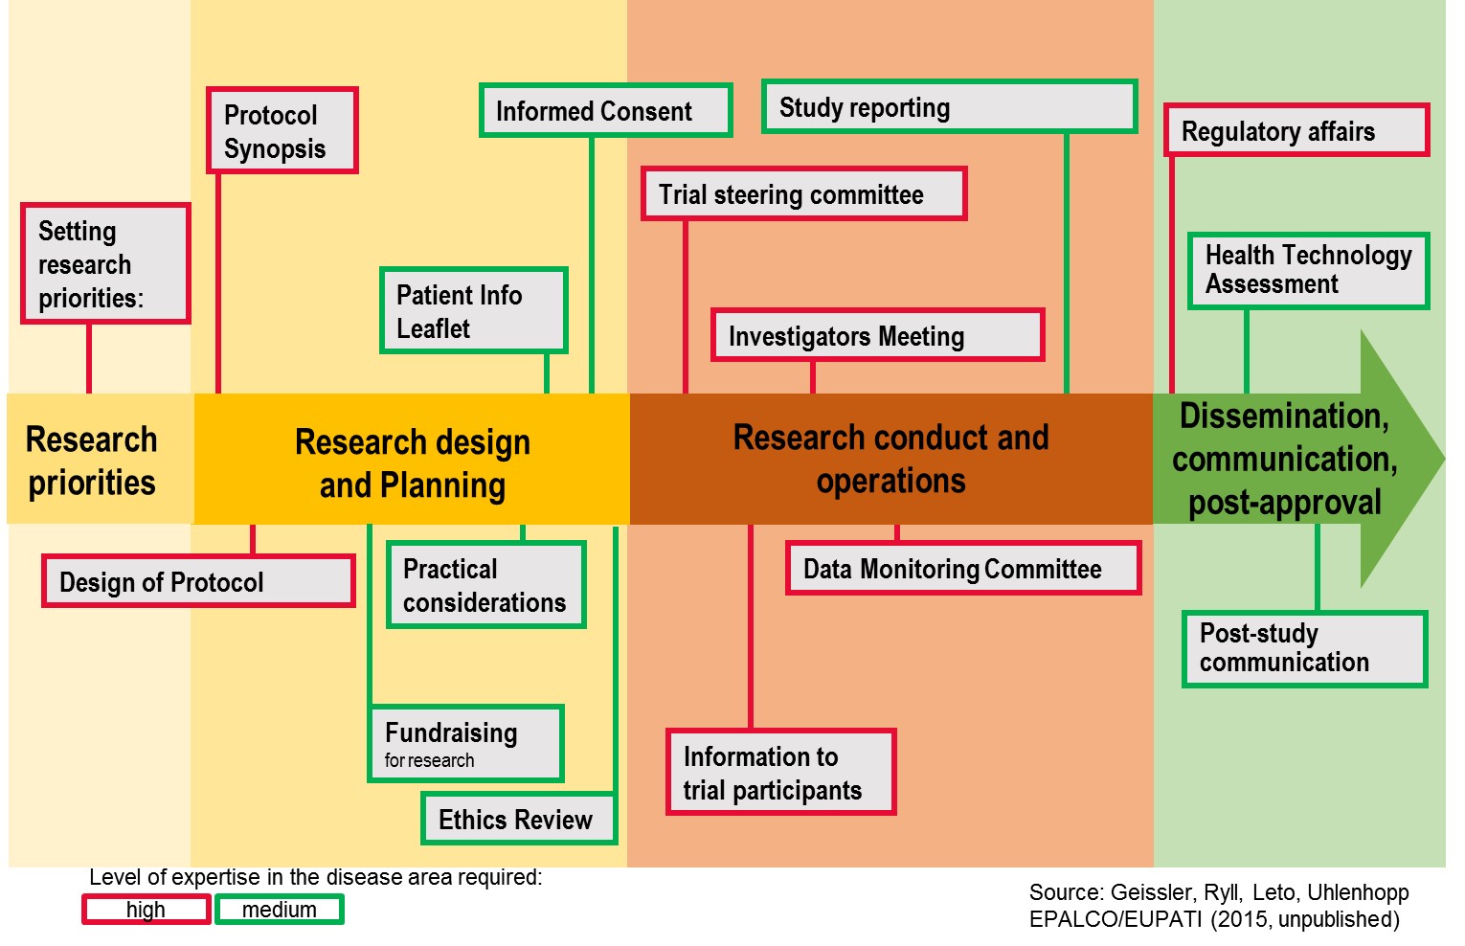

Appendix 2 – Template: Declaration of interest form
Conflicts of interest may arise when an individual's personal, business, occupational or professional interests or loyalties conflict with the interests of the project, and/or the projects principles on transparency, objectivity and independence. Public declaration and management of potential conflicts of interest are of major importance. A conflict of interest occurs when, in the course of their project activities, contributors are privy to decisions or documents that provide opportunities to obtain personal, business, economic, occupational or professional benefits for themselves and/or third parties.
Every member of the project performing any task in the project annually completes and updates this personal disclosure form describing his/her professional and non-professional activities and affiliations. This form takes into consideration e.g. Section 3 of the ICMJE's requirements for Disclosure of Potential Conflicts of Interest.
The completed forms are made publicly available and are regularly reviewed by the Ethics Panel. Identified potential conflicts of interest are reported to the project’s overseeing body for resolution.

Last name: _________________________________
First name: _________________________________

Postal address: ______________________________
____ __________________________
____ __________________________

I have no actual, potential, real or apparent interest to declare

- or -

I, the undersigned, hereby declare the following interests (e.g. affiliations, board membership, consultancy, employment, expert testimony, grants / grants pending, patents, royalties, other educational initiatives, stock/equity)
______________________________________________________________________________________________________________________________________________________________________________________________________________________________________________________________________________________________________________________________________________________________
Affirmation of Compliance
I have received and carefully read the project's objectives and Ethics Framework and have considered not only the literal expression of the policy, but also its intent. By signing this affirmation of compliance, I hereby affirm that I understand and agree to comply with the policy.
Unless otherwise indicated in the Disclosure Statement, I hereby state that I do not have any conflict of interest, financial or otherwise that may be seen as competing with the interests of the project or its principles on transparency, objectivity and independence.
If any situation should arise in the future that I think may involve me in a conflict of interest, I will promptly and fully disclose in writing the circumstances to the coordinator of the project.
I further certify that the information set forth in the Disclosure Statement is true and correct to the best of my knowledge, information and belief.

_____________________________________ ______________________
Signature Date

Appendix 3 – Template: Confidentiality agreement
Confidentiality Agreement Project Members

Project Member Mr/Ms. _____________________________________________ (full name),
hereinafter referred to as "the project member”
(Home address)____________________________________________________
_________________________________________________________________
_________________________________________________________________

And

_________________________________________________________________
(Legal representative for [insert name of the organisation]), hereinafter referred to as "the organisation".
Both parties signed below declare their intention and will to collaborate during organisation meetings and to work on [insert objective of activity].
To facilitate discussion it may be necessary for the organisation to provide information of a confidential nature (and of commercial value delete if not applicable). All such confidential information is hereafter referred to as "confidential information".
The organisation agrees to disclose the confidential information to the project members who agree to receive the same on the following conditions:
- Confidential information will be used solely for the purpose set out above and for no other purpose whatsoever. No conclusions, results or other material created as a result of the direct participation in the organisation presentations (hereinafter referred to as "the results") will be used without prior written consent from the organisation.
- All confidential information and results will be held in the strictest confidence at all times and will not be disclosed, as a whole, or in part, to any third party, nor will any third party be allowed to have access to the same or any part thereof without prior written consent granted by the organisation.
- The above mentioned limitations refer to material that is specifically mentioned as confidential and is of commercial or academic value and shall not apply to any other part of information or results.
It is agreed that the limitations mentioned above shall not apply to any part of information or results that:
- Were already known to any project member prior to its disclosure by the organisation;
- Are public knowledge or subsequently become known to the public other than by breach of this agreement;
- Are received without restriction from any third part that is entitled to disclose the information.

[insert name of organisation] e-mail list
Project members can join the [insert name of organisation] discussion list after attending the first [insert name of organisation] meeting, provided that the Declaration of Interest Form is completed and signed.
- All discussions and materials posted on this list are of confidential nature.
- Reposting or forwarding to other individuals or lists is not allowed.
- Reposting of information that is in the public domain is allowed, but has to be copy/pasted in a new e-mail, in order to protect the privacy of the original sender.

It is agreed that the member shall vest in the organisation all copyright, and any other intellectual property rights in the information, whether or not the results are selected for use and/or publication by the organisation.
If the foregoing is acceptable to both parties, they will indicate so by duly signing and dating the enclosed duplicate of the agreement.
On behalf of the organisation Project Member

___________________________ ______________________________
Place/Date/Signature Place/Date/Signature

Appendix 4 – Example written agreement

Appendix 5 – Codes of Practice Reviewed
During the EUPATI project it has been established that no existing code of practice specifically and sufficiently provides guidance on patient involvement in industry R&D. A number of recognised codes were reviewed to evaluate if language or statements could provide important foundation for this guidance document.
The following codes were identified and reviewed:
- EFPIA Code of practice on relationships between the pharmaceutical industry and patient organisations (EFPIA Patient Organisation (PO) Code)
- ECPC; EATG; EURORDIS; EPF; and IPPOSI Code of Practice Between Patients’ Organisations and the Healthcare Industry
- The ECAB Protocol (description of and working procedures of ECAB (European Community Advisory Board, scientific working group at EATG, established 1997))
- Mandate, objectives and rules of procedure for the European Medicines Agency Human Scientific Committees’ Working Party with Patients' and Consumers' Organisations (PCWP) (30 May 2013)
- Minutes of EMA Human Scientific Committees’ Working Party with Patients’ and Consumers’ Organisations (PCWP) meeting with all eligible organisations (31 January 2014)
- 10 December 2009 EMA Reflection Paper on the Further Involvement of Patients and Consumers in the Agency’s Activities
- EMA leaflet on working with patients and consumers (updated 22/4/2015)
- EMA framework of interaction (revised 16 October 2014)
- Recommendations from ECAB meeting held in Bergen, Norway 1997
EATG ECAB, “The impatient Patient - From Anger to Activism”
A systematic review of the history, working models, relevance and perspectives of the European Community Advisory Board
- FDA Patient Representative Program
- FDA Patient-Focused Drug Development; The Voice of the Patient: A Series of Reports from FDA's Patient-Focused Drug Development Initiative
- FDA Patient-Focused Drug Development: Enhancing Benefit-Risk Assessment in Regulatory Decision-Making
- WMA Declaration of Helsinki - Ethical Principles for Medical Research Involving Human Subjects http://www.wma.net/en/30publications/10policies/b3/index.html

Adapted from the EMA framework http://www.ema.europa.eu/docs/en_GB/document_library/Other/2009/12/WC500018013.pdf
Hoos A, Anderson J, Boutin M, et al. 2015, Partnering with patients in the development and lifecycle of medicines: a call for action. Therapeutic Innovation & Regulatory Science.
http://www.pcori.org/about-us
http://www.fda.gov/ForIndustry/UserFees/PrescriptionDrugUserFee/ucm326192.htm
http://www.ctti-clinicaltrials.org/
http://patientfocusedmedicine.org/

